

Smart White Cane

Supervised by:

[Belal H. Sababha, Ph.D.](https://elearning.psut.edu.jo/mod/url/view.php?id=158805)

Made By:

Ahmad Arafeh 20180589

Fouad Sharaiha 20180119

Omar Zalloum 20190646

**Abstract**

We created an improved version of the white cane using a PIC16F877A microcontroller and an ultrasonic sensor. We designed the cane to detect objects at a certain distance so it can provide feedback through a buzzer and a vibration motor, and as long as the cane is getting closer to the object the sound and the vibration will increase this will alert the user of the presence of an object ahead of him.

**Table of Contest**

1. ***Introduction………………………………………………………………. 3***
2. ***Design ………………………………………………………………...… 3***
   1. ***Parts and Prices ………………………………………………………3-6***
   2. ***Code ………………………………………………………………… 6-8***
   3. ***State Diagram …………………………………………………………. 9***
   4. ***Pin Diagram …………………………………………………………. 10***
3. ***Problems and Solutions …………………………………………………. .11***
4. ***Conclusion ………………………………………………………………. 11***
5. Introduction:

Blind people are some of the most unfortunate people on this planet and we want to make it easier for them to navigate around. One of the most helpful tools that was created for them is the white cane but still it didn’t solve everything. So we thought of a way to improve on it making it more useful and making it easier for them to walk around without worrying about hitting any objects in front of them, we even took it a step further in case the person was not only blind but deaf too by adding a vibrator motor with a buzzer so the user will be alerted whatever the circumstances that he’s in. The cane will release a sound and vibrate once it detects an object in front of it, the vibration and the sound will continue to increase as long as the cane is still approaching the object.

1. Design:
   1. **Parts:**

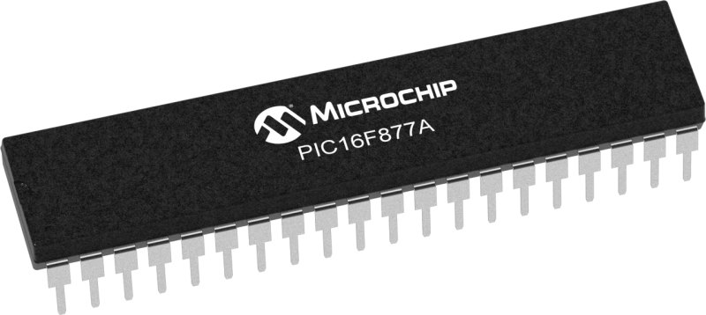

Figure (1): PIC16F877A.

Price: 7.99 JDs

Figure (2): Ultrasonic Sensor.

Price: 4.99 JDs

We placed it at bottom of the can so it can detect objects ahead of it.

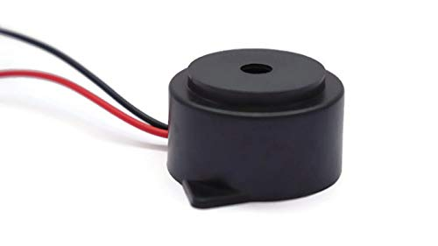

Figure (3): Buzzer.

Price: 0.74 JDs

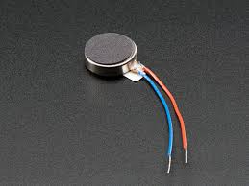

Figure (4): Vibrator Motor

Price: 0.74 JDs

We placed the buzzer near the grip so the user can feel the it’s vibration better.



Figure (5): 9V Kodak Battery.

Price: 1.49 JDs

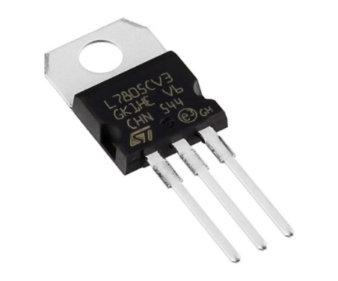

Figure (6): Voltage Regulator L7805cv.

Price: 0.24 JDs

We did not use this regulator in the end as it only allowed little current to pass it.

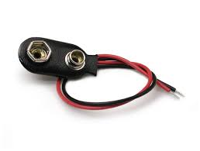

Figure (7): 9V Battery Snap Clip Lead Wire

Price: 0.24 JDs

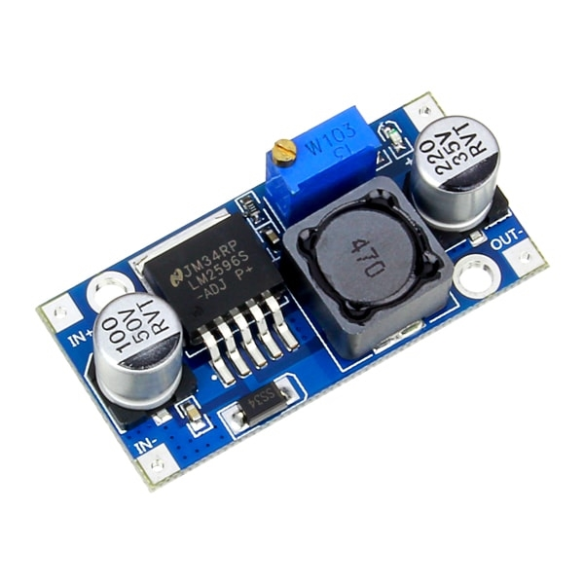

Figure (8): LM2596 DC-DC Buck

Price: 1.99 JDs

We connected it to the Snap clip so it can regulate the 9v of the battery to 5 so the PIC doesn’t burn.

* 1. **Code:**

// TRIGGER_PIN RB0 // Trigger pin for ultrasonic sensor

// ECHO_PIN RB1 // Echo pin for ultrasonic sensor

// BUZZER_PIN RB2 // Buzzer pin

// VIBRATION_PIN RB3 // Vibrator motor

unsigned int time=0;

unsigned distance=0;

unsigned int microseconds=0;

unsigned int i = 0;

void delay_us(microseconds) {

for ( i = 0; i < microseconds; i++) {

// busy loop

}

}

void main() {

// Set TRIGGER_PIN BUZZER_PIN ALSO VIBRATER as output pins

TRISB = 0x02; // All ports are output except port RB1 is input

// Set ECHO_PIN as an input pin

while (1) {

// Send a 10 microsecond pulse to the TRIGGER_PIN

PORTB = 0x01;

delay_us(10);

PORTB = 0x00;

// Wait for the ECHO_PIN to go high

while(!(PORTB & 0x02));

// Start timer

TMR1H = 0;

TMR1L = 0;

T1CON = 0x01; // Enable timer with 1:1 prescaler

// Wait for the ECHO_PIN to go low

while(PORTB & 0x02);

;

// Stop timer and calculate distance

T1CON = 0x00; // Disable timer

time = (TMR1H << 8);

distance = (float)time / 58.82; // Distance in cm

// Turn on buzzer if distance is 20 or less

if (distance <= 3) {

PORTB |= 0x04;

delay_us(9990);

PORTB &= ~0x04;

PORTB |= 0x08;

delay_us(9990);

PORTB &= ~0x08;

}

else if (distance >3 && distance <=10){

PORTB |= 0x04;

delay_us(3550);

PORTB &= ~0x04;

PORTB |= 0x08;

delay_us(6550);

PORTB &= ~0x08;

}

else if (distance >10 && distance <=15){

PORTB |= 0x04;

delay_us(1550);

PORTB &= ~0x04;

PORTB |= 0x08;

delay_us(3550);

PORTB &= ~0x08;

}

else if (distance >15 && distance <=20){

PORTB |= 0x04;

delay_us(990);

PORTB &= ~0x04;

PORTB |= 0x08;

delay_us(1990);

PORTB &= ~0x08;

}

else{

PORTB |= 0x04;

delay_us(200);

PORTB &= ~0x04;

}

}

}

* 1. **State Diagram:**

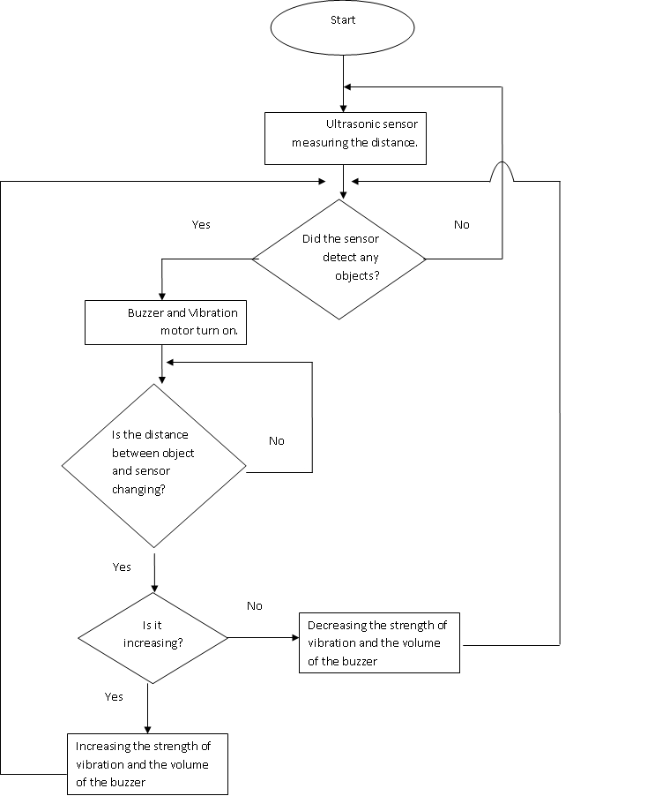

* 1. **Pin Diagram:**

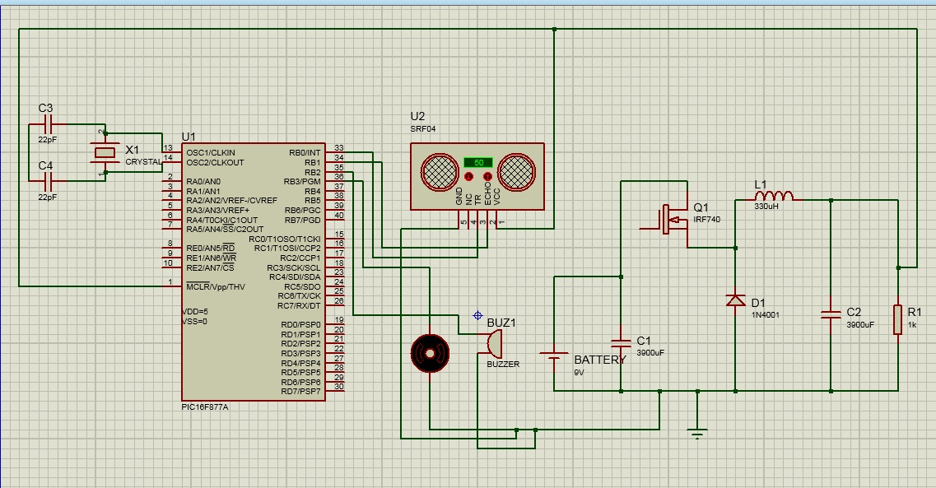

1. Problems and Solutions
2. The biggest problem we encountered was that we used a voltage regulator which didn’t give the microchip enough current to activate the system, we spent a long time trying to figure that out as it gave as a read of 5 voltages.

To solve this problem first we tried to add capacitors but after adding different ones nothing really happens and we were still stuck at the same problem.

So we decided to change form the voltage regulator that we were using to a DC-DC buck which solved the problem.

1. We had another problem with our code and especially with the PWM we miscalculated the needed frequency which caused many problems in the delay function.

We solved this problem by redoing the entire function with its calculations and it worked.

4. Conclusion

In conclusion, a smart, low-cost White Cane can be made to make blind people’s life way easier using basic items that can be found in any electrical shop, this project is a proof of concept that can be modified even further and more features can be added in the future.

Over this course we had learned everything we need to be able to complete this project. Even though we faced multiple obstacles software and hardware wise which includes damaging some components and other components not giving us our desired output, we were still able to complete this project that not only works but also have a way to benefit others. Our cane is able to detect distance changes which in return alters the strength or the vibration motor and the volume of the buzzer for the user to be able to have a feeling of their surroundings which makes it easier for people with impaired vision to move around comfortably and most importantly safely.